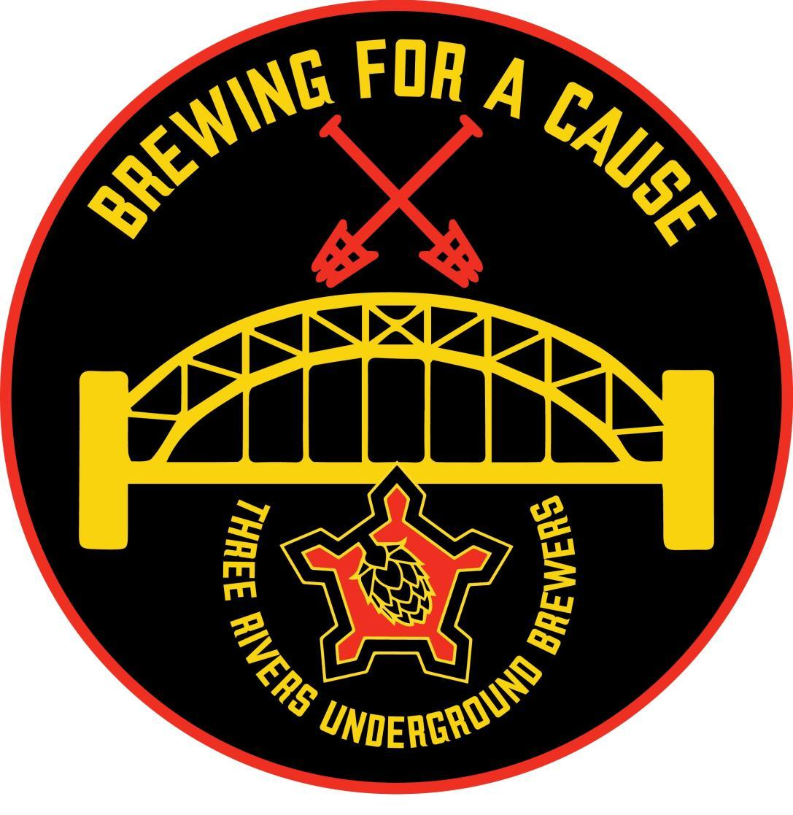

***Brewing For a Cause***

**Benefit for “Paws Across Pittsburgh”  
Presented by Three Rivers Underground Brewers  
Saturday - October 19, 2024  
Velum Fermentation, Pittsburgh, PA**

Three Rivers Underground Brewers (“TRUB”) will host the **16th annual Brewing For a Cause (“BFAC”)** on Saturday, October 19, 2024, at the Velum Fermentation in Pittsburgh, PA. This unique homebrew focused beer-tasting event benefits Paws Across Pittsburgh, and since its inception has raised over $355,000.00 for charity.

BFAC was started as a way for the members of TRUB to both promote home-brewing, and to support a cause that was close to all of their hearts. The money raised through BFAC is donated 100% to the charity selected by TRUB’s members.

We are asking that you consider donating to BFAC by providing an auction item. A gift basket, gift certificate, or other item would help to make this year’s event another huge success! You can feel good that your donation will go towards helping Paws Across Pittsburgh, a non-profit, foster-based animal rescue that works to rescue, rehabilitate, and re-home homeless, abused and unwanted dogs and cats.

I have attached a copy of our Donation Form, that you can complete and return. Auction items can be sent with your Donation Form to:

Three Rivers Underground Brewers

c/o Tom Zacher

834 Lilac Street

Pittsburgh, PA 15217

For cash donations, please make checks payable to Three Rivers Underground Brewers.

Your generosity will be recognized at the event, and we will help promote your business, by having your company’s name listed on our website, and in our on-line event program.

**Your charitable contribution is tax deductible.** **Paws Across Pittsburgh is a 501(c)(3) - EIN # 81-1807568.** If you have any questions, or would like to arrange pick-up of an item, please contact me directly at [tzacher@live.com](mailto:tzacher@live.com) or via phone at 412-251-9452.

Thank you for your support.

Tom Zacher

Brewing For a Cause

[www.brewingforacause.org](http://www.brewingforacause.org)