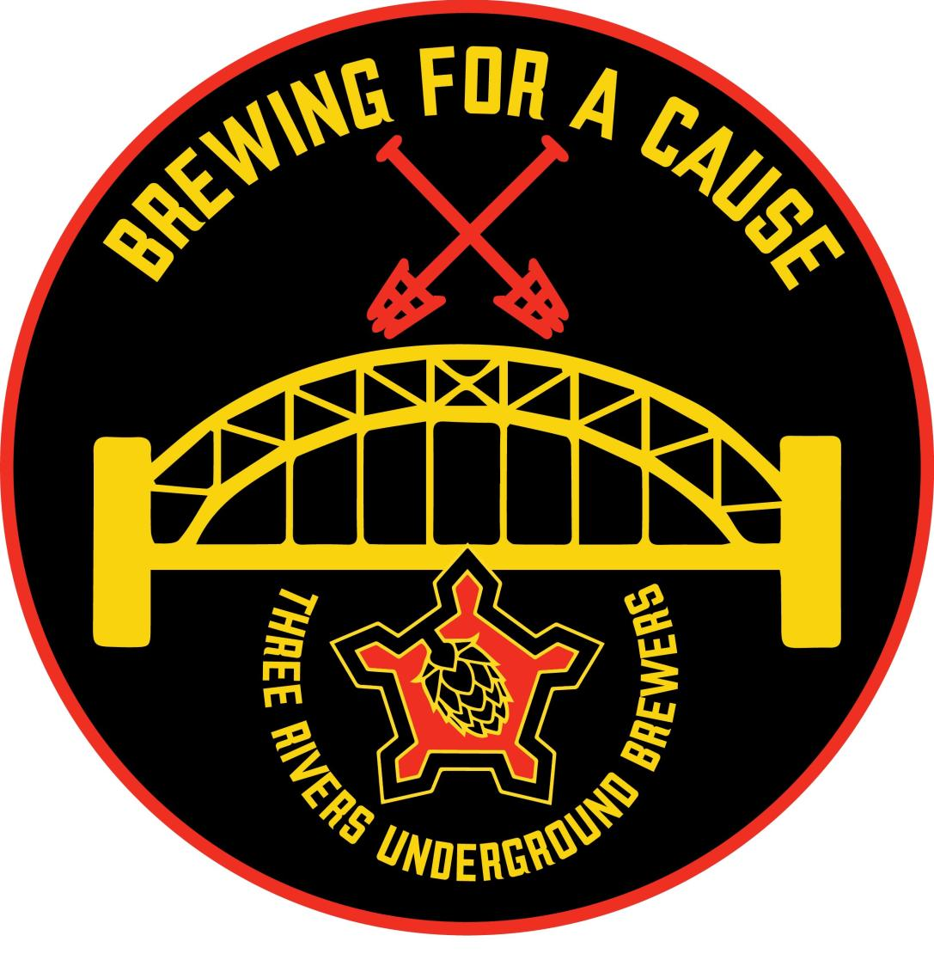

Brewing for a Cause - Charity Beer Tasting Event – October 19, 2024

Hosted by Three Rivers Underground Brewers

Sponsorship Form

Thank you for considering sponsoring the Brewing for a Cause Charity Beer Tasting Event organized by the Three Rivers Underground Brewers. Your support will make a significant impact on our charitable initiatives and help us make a difference in our community. Please fill out the following form to confirm your sponsorship level.

Sponsor Information:

Company/Organization Name: ____________________________________________

Contact Person: ________________________________________________________

Title/Position: _________________________________________________________

Address: ______________________________________________________________

City: _______________________________ State: _______ Zip Code: ___________

Phone: _____________________________ Email: ___________________________

Sponsorship Level:

Please select the sponsorship level you wish to contribute:

□ Gold Sponsorship ($1,000 and above)

□ Silver Sponsorship ($500 - $999)

□ Bronze Sponsorship ($499 and below)

Payment Details:

□ Check (Please make checks payable to "Three Rivers Underground Brewers.")

Sponsor Commitment:

By signing below, I/we commit to the selected sponsorship level for the Brewing for a Cause Charity Beer Tasting Event. I/we understand that payment must be received by September 15, 2023 to secure the sponsorship benefits.

Signature: ____________________________ Date: ___________________________

Please return this completed form to:

Three Rivers Underground Brewers

Attn: Michael F. Marks
107 Doubletree Drive
Venetia, PA 15367

mfmarks@comcast.net
C 412-225-1820

