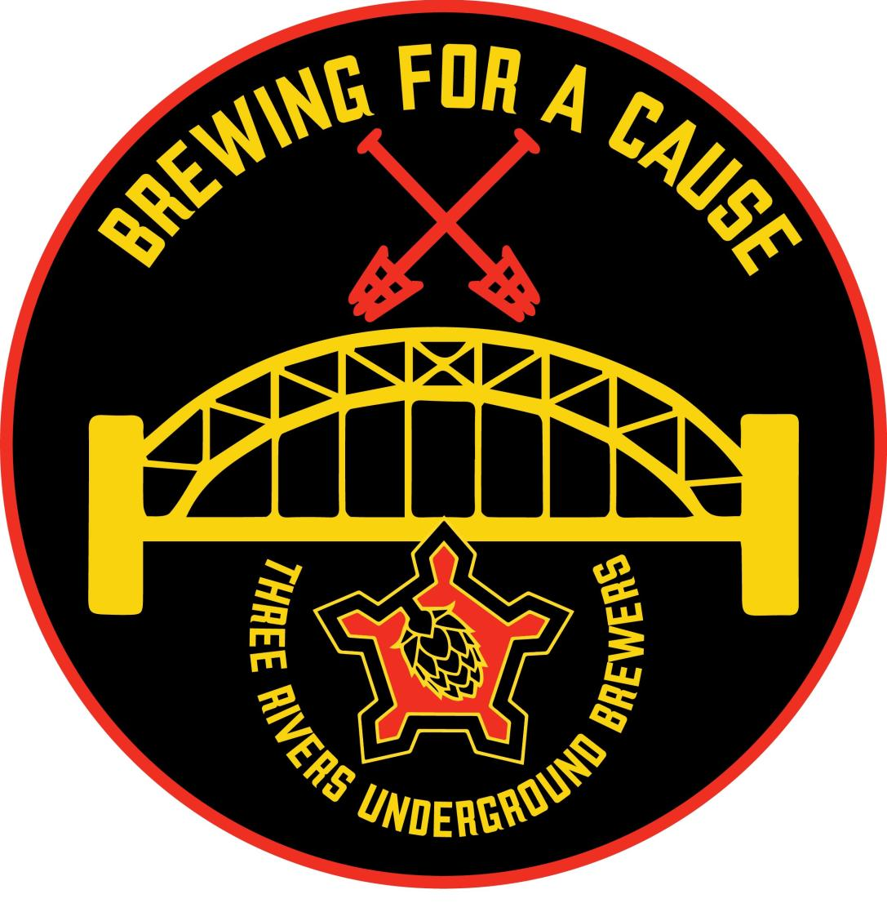

Three Rivers Underground Brewers (“TRUB”) is excited to announce our upcoming charity event, Brewing for a Cause (“BFAC”), which will take place on Saturday October 28, 2023 at the Energy Innovation Center – Pittsburgh, PA. As we strive to make this event a resounding success, we are reaching out to our valued community members and local businesses for support.

We believe in the power of BFAC to provide meaningful support to local non-profit organizations that are giving back to the community. To make it an exceptional experience, we are seeking sponsorships at various levels. We would be extremely grateful if you would consider becoming a sponsor at one of the following levels:

Gold Level Sponsorship: $1,000 and above

Silver Level Sponsorship: $500 to $999

Bronze Level Sponsorship: $499 and below

As a sponsor, your contribution will play a vital role in helping us achieve our goals and make a lasting impact on the pet rescue and adoption efforts of Paws Across Pittsburgh, a 501(c)(3) non-profit who is the charity that we are supporting this year. All net proceeds from the event are donated directly to the charity.

In recognition of your generosity, we offer a range of benefits that come with each sponsorship level:

Gold Level Sponsorship:
- Sponsorship recognition as host of catered food served at the event.

- Prominent placement of your company name and logo on the BFAC website.

- Verbal acknowledgement of your contribution during the closing ceremonies.

- 4 complimentary VIP tickets to the event.

Silver Level Sponsorship:

- Prominent placement of your company name and logo on the BFAC website.

- Verbal acknowledgement of your contribution during the closing ceremonies.

- 2 complimentary VIP tickets to the event.

Bronze Level Sponsorship:

- Prominent placement of your company name and logo on the BFAC website.

- Verbal acknowledgement of your contribution during the closing ceremonies.

- 1 complimentary VIP ticket to the event.

We genuinely appreciate your consideration of our sponsorship request and the support you provide to Brewing for a Cause. By becoming a sponsor, you will be joining a community of compassionate individuals and organizations committed to making a positive difference.

To confirm your sponsorship or discuss any details, please contact Michael Marks at:

c 412-225-1820 or mfmarks@comcast.net

Thank you once again for your support. Together, we can create a memorable event that brings our community closer and creates a lasting impact on many pets who will find a new home, and an owner who will properly provide for them. We look forward to the possibility of partnering with you and appreciate your generous contribution.

